**Vision Document**

COMP 354

**Prepared by:**

Vikram Singh - 26429513

Daniel Peris - 26568726

Yutong Yan - 40102938

Emre Kelleci - 40044269

Huy Nguyen - 40023289

Revision history

|  |  |  |  |
| --- | --- | --- | --- |
| Date | Revision Number | Description | Author(s) |
| 5/12/2018 | 1 | Initial vision documentation | Vikram Signh, Danniel Peris, Yutong Yan, Emre Kelleci, Huy Nguyen |

Table of content

1. **Introduction** …..…………………………………………………………………………………………………………….**4**
   1. Purpose ..……………………………………………………………………………………………………………………4
   2. Scope ..……………………………………………………………………………………………………………………….4
2. **Positioning** ..………………………………..……………………………………………………………………………….4
3. **Stakeholder** **Description** ..………..…………………………………………………………………………………..4
   1. Stakeholder Summary ....................................................................................... 4

3.2 User Environment .............................................................................................. 4

1. **Product Overview** ............................................................................................... **5** 
   1. Product Perspective .......................................................................................... 5

4.2 Assumptions and Dependencies ........................................................................ 5

4.3 Needs and Features ............................................................................................ 5

1. **Product Requirement** ..…………............................................................................. **6** 
   1. Platform requirements ...................................................................................... 6
   2. Hardware requirements ................................................................................... 6
   3. Performance requirements .............................................................................. 6
   4. Usability requirements ...................................................................................... 6
   5. Standards .......................................................................................................... 6
   6. Documentation .................................................................................................. 6
2. **Appendix** ............................................................................................................ 7

**1. Introduction**

**1.1 Purpose**

The purpose of this project is to be a part of the COMP 354 course, as well as giving each member of the team a chance to improve and practice both programming skills and communicated interactions. We will create a web application game for that purpose.

This vision document will give a vision of how the front-end on web browser interacts with the database on the back-end. The system will allow user to play a Pokémon card one-on-one with a small Artificial Intelligence (AI). It requires a real-time up-to-date database to record and to interact data value of the match. Furthermore, the game will have other features as required by the course such as display health or view ability.

**1.2 Scope**

This is a small basic game with just one-player mode. It will cover knowledge in web programming such as JavaScript or PHP.

**2. Positioning**

|  |  |
| --- | --- |
| By | Vikram Signh, Danniel Peris, Yutong Yan, Emre Kelleci, Huy Nguyen |
| For | COMP 354-section BB Concordia |
| The product | is a web application game |
| That | will function with real-time interaction |
| A successful product | has all of the features required and it not malfunction. |

**3. Stakeholder Description**

**3.1 Stakeholder Summary**

|  |  |  |
| --- | --- | --- |
| Name | Description | Responsibilities |
| Course evaluator | People who test the product | Test all different features of the product at real time |
| Software architecture | People who create the product | Designing and programing the product |

**3.2 User Environment**

Depending on size of Virtual Machine server given and permissions within it, we could set up 2 environment servers: staging or User Acceptance Testing and production. Otherwise, we will have to use the final server for both.

**4. Product Overview**

**4.1 Product Perspective**

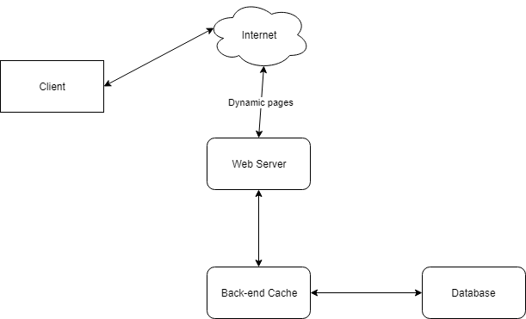

**4.2 Assumptions and Dependencies**

We will assume that the user will know the direct website location and already have an account to log in. The project given to us also has assume user will not log out during the game and required us to save the progress of the current match.

Dependencies will be on all of our using tools for the project and the server set up for us by the professor.

**4.3 Needs and Features**

|  |  |  |  |
| --- | --- | --- | --- |
| Need | Priority | Features | Planned Released |
|  | High | Game Starts | Iteration 2 |
|  | High | Decks Parse | Iteration 2 |
|  | High | Cards Dealt | Iteration 2 |
|  |  | Mulligans |  |
|  |  | Play Initial Pokemon |  |
|  |  | Bench Initial Pokemon |  |
|  |  | Draw Card at TurnStart |  |
|  |  | Play Items(if any) |  |
|  |  | Bench Pokemon |  |
|  |  | Evolve Pokemon |  |
|  |  | Place Energy |  |
|  |  | End Turn |  |
|  |  | Use Pokemon |  |
|  |  | AI Plays |  |
|  |  | Retreat Pokemon |  |
|  |  | Knock Out Pokemon |  |
|  |  | Collect Prize Card |  |
|  |  | Win |  |
|  |  | Lose |  |
|  | High | Check Both Hand Sizes | Iteration 2 |
|  | High | Check Both Deck Sizes | Iteration 2 |
|  | High | Check Both Discard Sizes | Iteration 2 |
|  |  | Look At Discards |  |
|  |  | Check Energy on Active Pokemon |  |
|  |  | Check Energy on Benched Pokemon |  |
|  |  | Look at Pokemon Abillity |  |
|  |  | Look at Abillity of Card in Hand |  |
|  |  | See Current Pokemon Health |  |
|  |  | See Max Pokemon Health |  |

**5. Product Requirements**

**5.1 Platform Requirement**

Since this is a web application game, we expected it to work on any browser on any operating system.

**5.2 Hardware Requirement**

*I don’t know about this, please fill in if you guys know*

**5.3 Perform Requirement**

We would like the game to run at a moderate time that is not too slow to load like loading database and setting up game like Football Manager game.

**5.4 Usability Requirement**

Usability is not a concerned in this project, anyone from the age of 4 should be able to enjoy the game.

**5.5 Standard**

Taking consideration of all our previous experience in coding lecture and the new content learnt from this course. For example, we try to work like a professional coding team in a SCRUM model. Also, we will document properly and be consistent with naming our variable since this is an open-sourced projects.

**5.6 Documentation**

All of this will be done through google doc drive that our team is using.

**6. Appendix A**